1. **What is meant by Design Pattern?**

* *Design patterns are reusable solution to the problems, they are generally targeted at solving the problems of object generation and integration.*
* *Patterns acts as a template that can be applied to the real-world design problems.*

*3 types of design patters:*

*1) Creational*

*2) Structural*

*3) Behavioural*

**2) What is the difference between Framework and Design Pattern?**

**Framework:**

* ***Framework****is a Skelton of code for developing particular type of application. For example, house can be treated as framework because it has predefined components like kitchen, bathroom, bedroom etc. Further it can be used to use to develop any type of house.*
* ***It is a collection of classes and interfaces which provides environment to develop an application***
* ***It is a product and part of system.***

**Design Pattern:**

* *Whereas a****design pattern****is a solution for particular problem. For example, design pattern for reusability.*
* *It is a way or methodology to develop an application*
* *It provides solution for similar kind of design patterns.*
* *It is a specification and part of system design.*

*3).* **What is Model?**

*Model represents specific data and business logic in MVC architecture. It maintains the data of the application. Model objects retrieve and store model state in the persistence store like a database.*

***4)* What is View?**

*View is a user interface. View displays data from the model to the user and also enables them to modify the data.*

*ASP.NET MVC views are stored in****Views****folder. Different action methods of a single controller class can render different views, so the Views folder contains a separate folder for each controller with the same name as controller, in order to accommodate multiple views.*

***5)* What is Controller?**

* *The Controllers in ASP.NET Core MVC application are the classes having a set of public methods. These public methods are called as actions (action methods).*
* *These action methods are the methods of a Controller which is actually going to handle the incoming HTTP Requests.*
* *The Controllers in MVC application logically group similar types of actions together. This aggregation of actions or grouping similar types of action together allows us to define sets of rules such as caching, routing, and authorization which is going to be applied collectively.*

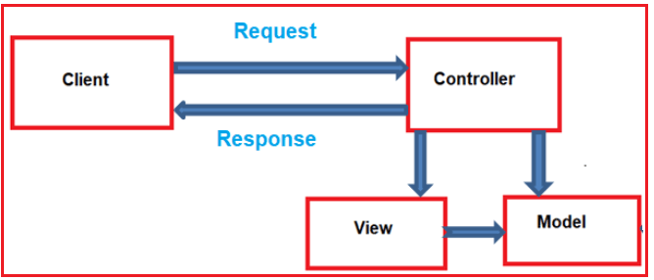

***6)* Advantage of ASP.NET MVC over ASP.NET Web forms?**

Advantages of ASP.net MVC are:

1. Enables the full control over the rendered HTML.
2. Provides clean separation of concerns (SoC).
3. Enables [Test Driven Development (TDD)](http://en.wikipedia.org/wiki/Test-driven_development).
4. Easy integration with JavaScript frameworks.
5. Following the design of stateless nature of the web.
6. RESTful URLs that enables SEO.
7. No ViewState and PostBack events

Main advantage of ASP.net Web Form are:

1. It provides [RAD](http://en.wikipedia.org/wiki/Rapid_application_development) development
2. Easy development model for developers those coming from win form development.

7) What is the ASP.NET MVC Version installed in your machine?

*ASP.NET MVC 5.2.7*